Peak1:

[[Model]]

Model(gaussian)

[[Fit Statistics]]

# fitting method = leastsq

# function evals = 33

# data points = 128

# variables = 4

chi-square = 548349.58761

reduced chi-square = 4422.17409

Akaike info crit = 1078.41767

Bayesian info crit = 1089.82579

[[Variables]]

amp: 3002.35258 +/- 32.18150 (1.07%) (init= 65000)

cen: 884.280542 +/- 0.128888 (0.01%) (init= 885)

wid: 29.3103983 +/- 0.391582 (1.34%) (init= 15)

const: 152.784960 +/- 35.24753 (23.07%) (init= 100)

[[Correlations]] (unreported correlations are < 0.100)

C(wid, const) = -0.938

C(amp, const) = -0.934

C(amp, wid) = 0.804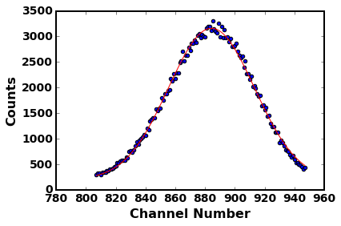

Peak2[[Model]]

Model(gaussian)

[[Fit Statistics]]

# fitting method = leastsq

# function evals = 33

# data points = 85

# variables = 4

chi-square = 23740.46183

reduced chi-square = 293.09212

Akaike info crit = 486.74421

Bayesian info crit = 496.51482

[[Variables]]

amp: 306.699965 +/- 11.83863 (3.86%) (init= 3000)

cen: 1457.10507 +/- 0.288984 (0.02%) (init= 1458)

wid: 21.5074523 +/- 0.941354 (4.38%) (init= 15)

const: 101.939707 +/- 12.82371 (12.58%) (init= 100)

[[Correlations]] (unreported correlations are < 0.100)

C(amp, const) = -0.956

C(wid, const) = -0.943

C(amp, wid) = 0.841

C(amp, cen) = -0.159

C(cen, const) = 0.155

C(cen, wid) = -0.117

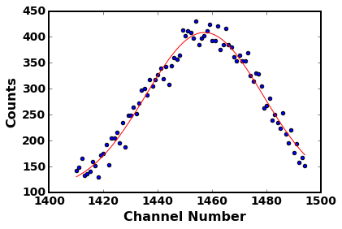

Peak3[[Model]]

Model(gaussian)

[[Fit Statistics]]

# fitting method = leastsq

# function evals = 33

# data points = 80

# variables = 4

chi-square = 17917.89609

reduced chi-square = 235.76179

Akaike info crit = 440.92229

Bayesian info crit = 450.45040

[[Variables]]

amp: 303.465689 +/- 13.29012 (4.38%) (init= 3000)

cen: 1568.26320 +/- 0.249069 (0.02%) (init= 1571)

wid: 20.3321511 +/- 0.978885 (4.81%) (init= 15)

const: 68.1004487 +/- 14.48589 (21.27%) (init= 100)

[[Correlations]] (unreported correlations are < 0.100)

C(amp, const) = -0.970

C(wid, const) = -0.960

C(amp, wid) = 0.891

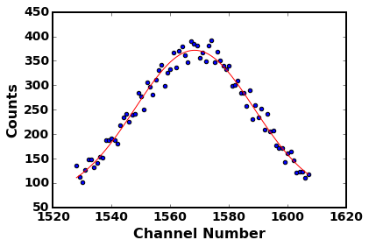

After, peak1

[[Model]]

Model(gaussian)

[[Fit Statistics]]

# fitting method = leastsq

# function evals = 28

# data points = 128

# variables = 4

chi-square = 915317.11803

reduced chi-square = 7381.58966

Akaike info crit = 1143.99944

Bayesian info crit = 1155.40756

[[Variables]]

amp: 3925.87989 +/- 33.95947 (0.87%) (init= 3000)

cen: 848.328460 +/- 0.122841 (0.01%) (init= 850)

wid: 27.4900571 +/- 0.316899 (1.15%) (init= 15)

const: 259.058606 +/- 36.66641 (14.15%) (init= 100)

[[Correlations]] (unreported correlations are < 0.100)

C(wid, const) = -0.917

C(amp, const) = -0.894

C(amp, wid) = 0.715

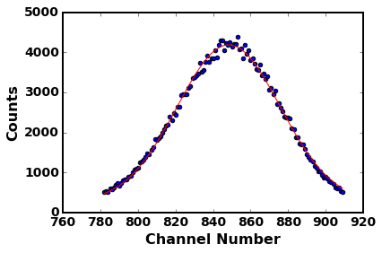

Peak2[[Model]]

Model(gaussian)

[[Fit Statistics]]

# fitting method = leastsq

# function evals = 38

# data points = 108

# variables = 4

chi-square = 55872.78992

reduced chi-square = 537.23836

Akaike info crit = 682.85977

Bayesian info crit = 693.58829

[[Variables]]

amp: 408.451374 +/- 9.545423 (2.34%) (init= 3000)

cen: 1414.40398 +/- 0.290374 (0.02%) (init= 1415)

wid: 22.8643274 +/- 0.720967 (3.15%) (init= 15)

const: 104.131449 +/- 10.23765 (9.83%) (init= 100)

[[Correlations]] (unreported correlations are < 0.100)

C(wid, const) = -0.910

C(amp, const) = -0.882

C(amp, wid) = 0.689

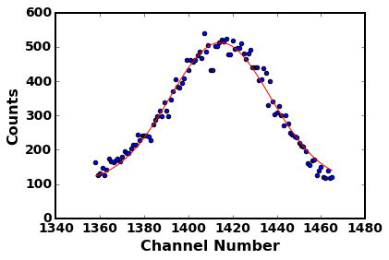

Peak3[[Model]]

Model(gaussian)

[[Fit Statistics]]

# fitting method = leastsq

# function evals = 33

# data points = 97

# variables = 4

chi-square = 44198.59229

reduced chi-square = 475.25368

Akaike info crit = 601.80851

Bayesian info crit = 612.10736

[[Variables]]

amp: 394.196685 +/- 9.746754 (2.47%) (init= 3000)

cen: 1526.30732 +/- 0.269507 (0.02%) (init= 1529)

wid: 20.7274074 +/- 0.686064 (3.31%) (init= 15)

const: 77.8694910 +/- 10.50101 (13.49%) (init= 100)

[[Correlations]] (unreported correlations are < 0.100)

C(wid, const) = -0.915

C(amp, const) = -0.890

C(amp, wid) = 0.706

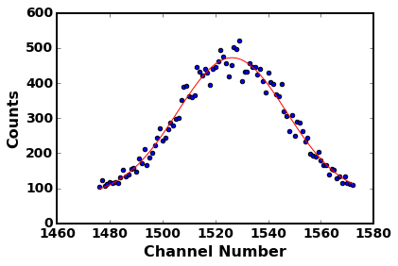

CalibBefore Channel vs Energy

(array([ 192.53670114, 1.04718725]), array([[ 2.32775726e+03, -2.51253309e+00],

[ -2.51253309e+00, 3.00890204e-03]]))

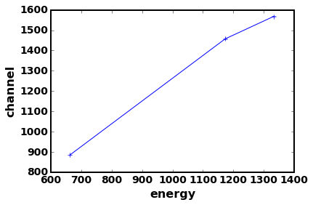

CalibAfter Channel vs Energy

(array([ 161.00108743, 1.04023941]), array([[ 2.11641887e+03, -2.32518841e+00],

[ -2.32518841e+00, 2.82627285e-03]]))

